06.02 Delays & Event Tracking
Process Design & AMOS Configuration Document
Purpose
This Process Design document is provided to Key-Users to record their key decisions regarding the AMOS Process design and the required AMOS configuration.
It is updated throughout the Project Definition Phase and used as the baseline for the Final Acceptance prior to Go-Live
Revision
Author, Name | Date | Notes
FREL | 07.08.2024 | First Version
BENX | 18.11.2024 | Process Flow updated

Table of Contents
1. Process Overview & Objectives 3
2. Regulatory References 3
3. Definitions & Glossary 4
4. Process Tasks 5
5. Process Dependencies 5
6. Process Flow 6
7. Process Design Questions 7
8. Data (Source) Mapping 8
9. Other Software Used 8
10. AMOS Configuration 8
a. Basic Data 8
b. Parameters 9
c. Workflows 10
d. Scheduled Tasks 10
e. API’s & Interfaces 10
11. Annex – Additional Info 11
a. Manual Entry of Delays 11
b. Automatic Import of Delays (via OPS interface) 11
c. Occurrence Reporting to the Authority 11
d. Event Tracking Setup 12
e. Duty of the MCC 13
f. ACARS Messaging 13
g. Reporting 13

Process Overview & Objectives

Process General Description:
This process is usually executed by the Maintenance Control Center (MCC) department of an Airline.
The delays & event tracking process is a requirement to then be able to properly track operational events, generally avoid unplanned ground times and optimise aircraft dispatch reliability.
The trigger of this process is an event or a problem reported by a crew or a technical staff. The output of this process is the proper tracking and reporting of these events to be dealt with further in other business processes.
The main benefits identified for the organisation when fully adopting this process are the following:
- Overall Economy – cost reduction: A precise tracking of aircraft and station events can allow to avoid unwanted ground times and optimise dispatch reliability which leads to better economical performance from the airline.
- Process improvement: By an appropriate record and tracking of events, this information can be automatically disseminated and reused in other modules avoiding duplication of data entry and improving overall data quality.
- Internal management: Appropriate tracking of such events and enhanced data quality allows for more precise data analysis and enhanced internal steering.

Main Process Objective (Outputs & Outcomes):
The main stake holder involved in this process is Maintenance Control Center (MCC) department. This department is usually responsible for recording and managing all aircraft and station related events during operation hours.
For event tracking, unplanned maintenance activities due to technical faults should be minimized as much as possible. It is not easy to prevent a technical interruption during flight operations. However, repetitive failures can be largely avoided in the future by analysing these incidents together with historical maintenance data of similar occurrences. By analysing an unplanned maintenance event, it is easy to understand the root causes. Downstream measures can then lead to predictive maintenance activities which can lead to substantial cost savings.
The MCC / MOC often also forms the link between the Part M / CAMO and the Part 145 organization. Either CAMO Planning accepts the CRS request of Part 145, or this task is contractually delegated to the MCC / MOC.
For delays, this process is intended to evaluate data that has either been manually created in Event Tracking or data that has been automatically supplied by an OPS system. The result is the "Technical Aircraft Dispatch reliability". In addition, the Technical Availability Performance can be used to provide a percentage availability of an aircraft. A simple reporting tool can be used to determine the unscheduled ground times. Finally, the data is also used in the standard reliability tool.

Regulatory References

The main regulatory references identified for this process are the following:
- EASA Part-M – M.A.301

Definitions & Glossary

Key-Words | Explanation
Event | An "Event" is in this context an unscheduled interruption of the aircraft operation. The nature of the event can be technical, operational or e.g. environmental
Aircraft Event | An aircraft-event is a operational interruption which is related to an aircraft registration (e.g. HB IZG)
Station event | A station event is related to a station (airport, e.g. Kuwait International Airport (KWI)) It describes a situation on this airport that interrupts the operation. It could be a strike of the ground personal or a weather situation (Sandstorms e.g.). The reason of such an interruption is in the most cases known in advanced.
OPS Consequence | Describes the operational impact of the event (AOG etc. Can be amended in the AMOS Basic Tables)
Classification | Every event requires a classification to recognize the source of the interruption (technical, operational, environmental)
Advise time | The Advise-Time is the time that the Maintenance Control Center (MCC) communicates to the Airline Operational Center (OCC). It is used to tell OCC at which time the aircraft is available for service again, or it is just the time until the next update of the event will be send to the OCC. AMOS uses the so called “negative advise-time” (= next update, the aircraft will be NOT available to this time) to update the OCC. The “positive advise-time” is to tell the OCC that the aircraft will be at the mentioned time back to service.
Experience Sheet | This is a tool (APN 217) where you can collect individual knowledge to provide it as an common knowledge database. E.g., it records experience/findings that recur with the troubleshooting process and their outcome, which helps in the fault-finding process for similar events in the future. Be aware that the Experience Sheet is never a replacement of the OEM Trouble Shooting Manuals. It is used to give “hints” how the trouble shooting can be more efficient IAW with the company’s experience. The types of document (Technical Info Flash, Experience Sheet, and Technical Publication Query) that are available are defined in Basic-Data Administration (APN 18).
IFSD | Inflight Shut Down (IFSD) give direct access to the APN 758. With IFSD Tracking, AMOS offers the possibility to track, for example, engine or APU shutdowns and generate graphs that can be printed in a report to present to the ETOPS organization.
UGT | Unscheduled Ground Time (customer specific)
OCC | Operations Control Center
Consequence | Basically, a delay, cancellation, turn around, deviation…
Delay Code | A delay code is a unique number within an IATA numbering system, where a delay (technical or operational) can be classified.

Process Tasks

Main Process Task / Actions / Activities:
The following actions are performed in this Business Process:
- Create a new Station event: When an event linked to a station occurs (strikes, sandstorm, …), the MCC staff creates a Station event as a record in the database. This event will then be processed in the system.
- Create a new Aircraft event: When an event linked to an aircraft occurs (Crew report, operational event, …), the MCC staff creates an Aircraft event as a record in the database. This event will then be processed in the system.
- Record all communication details & actions: When additional information arrives for a specific event, the MCC staff can record these with the event. This allows to bundle the event linked information in one area to make it available to all users.
- Compare event tracking delays & cancellations: This program is only available when an interface to an external OPS system is available. The MCC staff can compare the event, delays and cancellation data from one system to another. Please refer to chapter 11.b for more details.
- Retrieve delays & cancellations: In this step the MCC staff can easily retrieve information regarding flight delays and cancellations for a specific aircraft or a period of time. The data displayed in Delays & Cancellations is provided by Event Tracking. Smaller airlines that do not use Event Tracking can also perform manual single entries into this program. Please refer to 11.b for more details.

Process Dependencies

The following process dependencies were identified for this process:
- 06.03 – Line Maintenance Oversight: Line maintenance data may serve as inputs for this process to allow the MCC team to have a good overview of what Line maintenance activities are on going.
- 06.01 – Fleet Status Monitoring: The events reported in this process will feed the fleet status monitoring feed and vice versa to allow the MCC staff to have a good overview of the fleet status.
- 06.04 – Recurrent Defects: This process will feed the recurrent defects process to assist in reliability calculations and analysis.
- 06.05 – Aircraft Incidents: This process will be one of the initiators of the aircraft incident process if required.

Process Flow

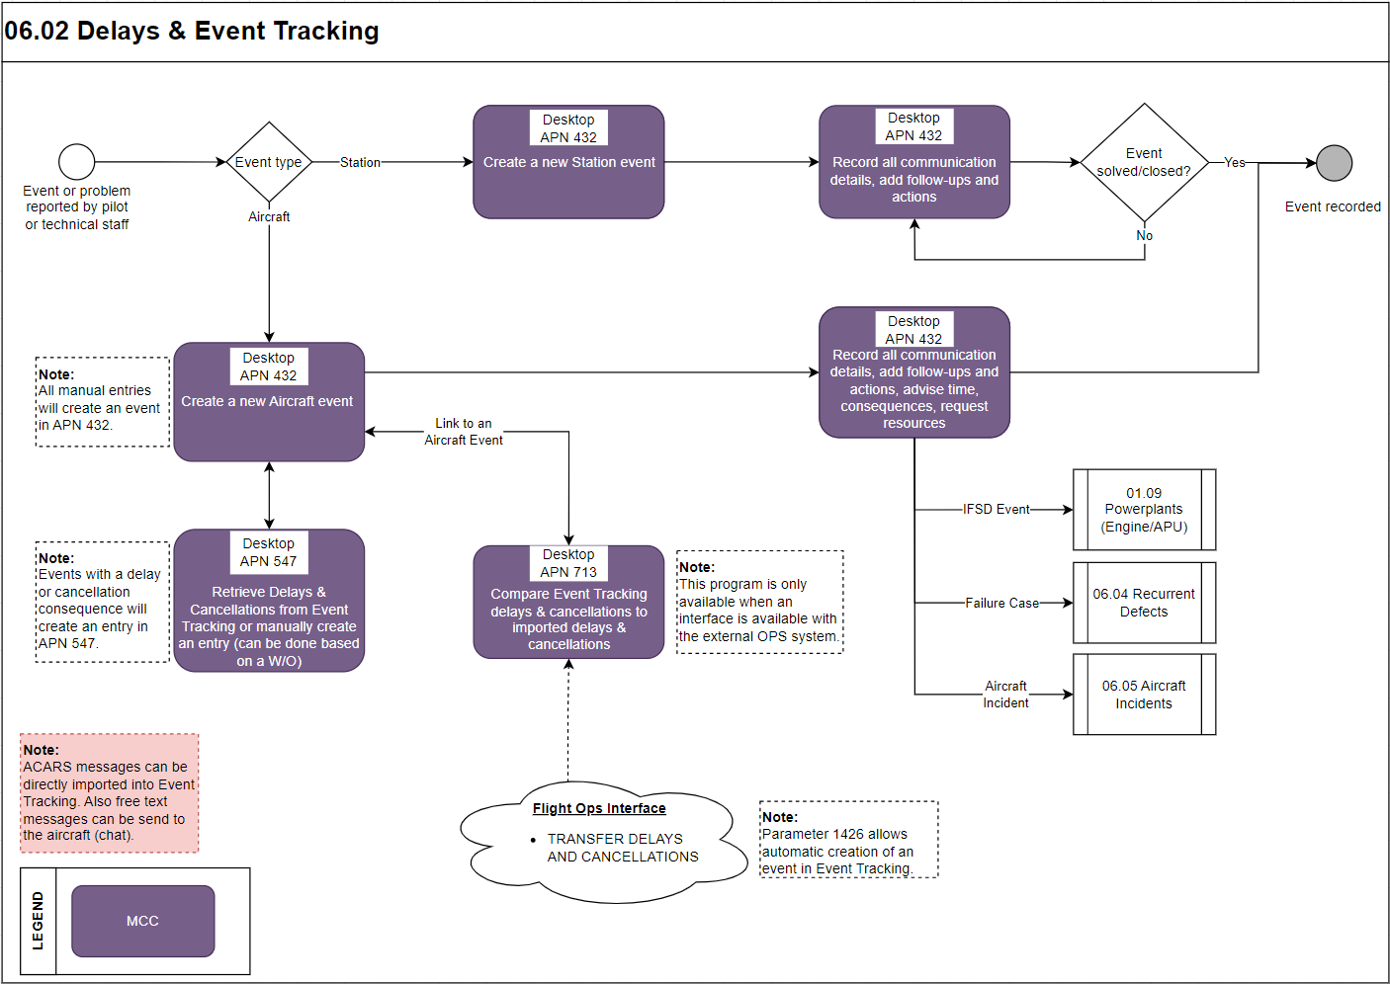

Process Design Questions

# | Question | Answer
1 | How many persons are working in your MCC and what are their roles
2 | What kind of shift systems applies to your MCC
3 | Describe your MCC process
4 | Describe your Trouble Shooting Process
5 | Who is dealing with delay and cancellation codes?
6 | How is the AOG desk collaborating with the MCC?
7 | How is the CAMO Short-Term-Planning role collaborating with the MCC?
8 | Describe the MCC setup of your organization in relation, Part 145 for MRO's to customers, or in relation Part 145/CAMO
9 | Does your organization have MRO customers that receive line maintenance support exclusively?
10 | If the pilots of a third-party customer have an unscheduled event at one of the airports where your company operates, what is the process for the third-party customer to get support from your organization?
11 | Who in your organization (department) concludes contracts (line maintenance support) with external customers and how does this department communicate with the MCC? (Does the MCC know the content of these contracts so that the MCC knows which service has to be delivered to which customer?)

Data (Source) Mapping

Data Sources | Description | Volume / Manual / Automatic / Static / Dynamic
-Nil-

Other Software Used

Other Softwares | Used by: | Description
-Nil-

AMOS Configuration

Basic Data

Basic Data Table | Notes
Event Groups | Every event in Event Tracking can have an classification associated with it. A classification consists of a group and a type. First you have to define the groups then you have to define the types for every group (see table "Event Types")
Event Types | Every Event in Event Tracking can have an classification associated with Event Types. A classification consists of a Group and a Type.
OPS Consequence | The Events in Event Tracking can be marked as "OPS consequence". There you will find a drop-down box to select an consequence from.  Please note:  This drop-down box will only appear if you have at least on entry in this table.
Operations Phase | Defines the flight phases
Incident Types | Then marking an Event in Event Tracking as Incident you can specify an type from a drop down box.
Advise Classifications | Example: IFP "Information for pilot", IFO "Information for OPS"
Communication Types | specify how you were informed
Consequence Reason Groups | Example: LO LOGISTICS, MA MAINTENANCE, PL PLANNING
Consequence Reason Types | Example: LO LO_LMP Lack of Manpower; EN EN_NP No Procedure; MN MN_AMW AMM Wrong
Consequence Type | Consequence types used in application Occurrence Reporting when adding a new consequence.

Parameters

Parameter Code | Parameter Name | Notes
1216 | AET LOG OPS-CONSEQUENCE CHANGES | Activates/Deactivates logging of OPS Consequence changes.  If you set the string value of this parameter to "Y" logging is activated.  Whenever the OPS Consequence is changed the change is logged as a note.
1225 | ACTIVATE CASES IN AET | When you set the string value of this parameter to "Y" you activate the failure cases in the aircraft event tracking. Once activated it is possible to classify an event by assigning it to a failure case. If you set this parameter to "N" it is not possible to assign events to a failure case.
1231 | AET USES UTC TIME | Used by aircraft event tracking module. If you set this parameters String value to "Y" the times suggested by the input fields in AET will be in UTC. Additionally, all user input times are marked as UTC.  Note that this only affects the user input times and dates (e.g. event occurrence date), as modification times and creation times always will be set to server time.
1426 | DELAY-IMPORT AIRCRAFT EVENT TRIGGER | This parameter provides the means to trigger the creation of an aircraft event with an associated delay or cancellation when the automatic flightlog import detects a delay or cancellation in the import data. This parameter can be used, if one imports delay / cancellation data with the Amos-Netline Phase 2 interface or with XML structured content (via files or Message Broker)
1363 | FREE MEL EDIT (ALLOW UNKNOWN MEL REFERENCES) | If you set this parameters Amount[String] value to "Y " you can freely enter MEL chapters into the MEL field when creating a new event.  The MEL chapter codes are then no longer checked against the AMOS internal MEL Book.  This is useful for customers that do not want to maintain the MEL chapters in
1544 | SHOW OCCURRENCE TYPE COMBO BOX INSTEAD OF OCCURRENCE NO FIELD | If the parameter`s String value is set to Y the Occurrence Type combo-box will appear in the Event Dialog.  The Data from the Occurrence Type combo-box has to be defined in the Basic Table Occurrence Types of the program Basic Data Administration (APN 18)

Workflows

Workflow Number | Workflow Name | Notes
17 | Create failure case | This workflow is triggered when you create a Short-Term Failure Case out of an aircraft event in Event Tracking.
38 | New consequence | This workflow is triggered when a new consequence is saved for an event in Event Tracking. If a consequence entry is edited and saved this workflow is not triggered again.
56 | Event saved | Only valid for aircraft events. This workflow is triggered when an AET event is saved. You can check the reason wildcard if you need to determine the reason for the saving. This can be New, Edit, Closed, etc. See the wildcard description for a list of available values.

Scheduled Tasks

Scheduled Task Reference | Frequency | Notes
FlightOpsImportTask | 5mn | 4718

API’s & Interfaces

Reference | Direction | Trigger | Frequency
EXPORT AIMS MAINTENANCE EVENTS | Export maintenance event (workpackage) information to the AIMS system. | TBD | A/R
EXPORT NETLINE GROUNDEVENT | Export workpackages from AMOS to netline as ground-events. | TBD | A/R
EXPORT SABRE GROUNDEVENT | Export workpackages from AMOS to Sabre as ground-events. | TBD | A/R
EXPORT WORKPACKAGE EVENT PLANNING | Exports planning information of maintenance events included in the workpackages. | TBD | A/R
TRANSFER EVENT | Export aircraft/station event data. | TBD | A/R
IMPORT ACARS MESSAGE | Import of ACARS messages, used in APN 2543 ACARS Messaging | TBD | A/R

Annex – Additional Info

Manual Entry of Delays

Delays and cancellations are entered manually in the Program Event Tracking under an event. Use the data entry mask “Consequences”. Every entry here will be collected in the program “Delays and cancellations”.

Automatic Import of Delays (via OPS interface)

The program Technical Delays and Cancellations (APN 713) is fed by the AIM interface “Transfer Delays and Cancellations” directly from any OPS system. For the interface to run, you have to define the delays code using the standard codes in your OPS system. If one delay has e.g. 1 hour of total delay: 20 min for technical and 40 of any other not technical code, AMOS transfers this delay, reporting both delay codes and times.
Nevertheless, for reliability purposes only the technical delay (40-codes) are considered. Please note that the AIM interface "IMPORT AIMS DELAYS AND CANCELLATIONS" is capable to transfer 3 delays only, whereas the first delay is the leading delay.
You can link any delay to an event entered in the event tracking. If the delay duration or the delay code is changed in the event tracking and not matching anymore with the OPS imported delay code/time, a “D” will be indicated in column "AET DIFF".
All technical delays and cancellations transferred to APN 713 can be used to retrieve the dispatch reliability data based on the formula defined in APN 713 → setup. All formula are based on parameters which are available in the setup program and are referring to a specific data entry (so called place holder). Thus the placeholder can be used to calculate the different scenarios e.g. Technical dispatch reliability considering delays only greater then 15 mins, etc. The formula should be setup based on generic reliability calculations (IATA recommendations) and can be customized with operator specific requirements.
In addition, aircraft technical delays can be marked as chargeable which indicated that the aircraft delay is caused by an aircraft manufacturer issue (e.g. system deficiency known by Airbus).

Occurrence Reporting to the Authority

In the Event Tracking: flag the event as “occurrence” when the event needs to be reported to the authority as occurrence report. You can then call this event in the program Occurrence Report and issue the report to the authority directly from here.

Event Tracking Setup

The minimum setup for an MCC role are:
Maintenance Controller (MC)
The background of the MC is aircraft maintenance, he is experienced. The MC ensure all communications between operator and maintenance organization during an unscheduled aircraft- or station event. He ensures that the AMOS Event Tracking (APN 432) is according their processes used and updated. Finally, he close the events. This ensures a full report of all aircraft/station-events of his shift. The special talent of an MC is, he can communicate to all level of staff (from aircraft cleaner up to the management, Post Holder Maintenance), he can keep the overview in stressful situations, and he is able to organize. He knows and understands all relevant processes in the organization. His shift work-time starts often two hours before the first flight of the day and ends not before the last flight of the day has landed. It requires minimum two shifts per day. In some organizations the MC’ are working 24/7.
Trouble Shooter (TS)
The TS’s background is aircraft maintenance. It is common that a shift has different TS's per aircraft system (Avionic, System Engine). His duty is to support the engineers on line maintenance. With the support of TS’s, line-engineers can work more effective, since they can concentrate on the aircraft's problem. The TS check during his shift all unscheduled opened Workorders (WO) to ensure plausibility. Keep in mind that the unscheduled maintenance events are the basic information for the dispatch reliability. The TS always reviews the history of the concerned aircraft's or components. He gives advice's for the troubleshooting process. He issues the "short-term cases" if required. He ensures that the event tracking is properly update to guarantee a proper hand-over to the next shift. The special talents of TS’s are, he is able to work concentrated on one particular issue. He has a high level of knowledge of the aircraft systems. He communicates with the engineering of the Part M and maintenance engineers. His shift work time starts often two hours before the first flight of the day and ends not before the last flight of the day has landed. It requires minimum two shifts per day. In some organizations the MC’ are working 24/7.
Optional roles in MCC
Deepening of the size of the organization an MCC can have a different setup
Short-Term Planner
The Planner in an MCC (Production Planner of the 145 organization) can be responsible for all kind of checks up to the Phase A-Check. He planes all related workPackages. In the most organizations the Planner are working in a two shift per day system and six days a week. The workplace of the short-term planner must not be necessary in the same offices as the MCC, but if a good communication need to be established.
(In most cases, Short-Term Planners do not report directly to the MCC. However, CAMO Planning should provide a Short-Term Planner role that serves as a single point of contact (SPOC) for the MCC).
AOG Desk
The AOG-Desk is the single point of contact for MCC Department. The purchaser, responsible for the AOG desk, is a role that belong with all his privileges to the procurement department. The AOG desk purchaser requires a special process for the approval (amount for the purchase) since he need to get approvals 24/7 at almost every level. The AOG desk can, depending of the size of the organization, work in a 5/2 shift in the office and covering the other times on-duty regulations, working remotely. AMOS supports this.

Duty of the MCC

The MCC shall be the single point of contact (SPOC) for all unscheduled events. MCC belongs to the Part 145 and reports in their organization directly to the Head of Maintenance. MCC reports per contract or process as well to the CAMO. MCC’s duty is to find the fastest and/or economical way, considering the approved processes, to bring an aircraft back to services. In case of an AOG the MCC have to all time full control and organizes all resources required. It must be determined to what level of effort the MCC remains responsible for the AOG before the AOG aircraft is maybe handed over to the CAMO / Planning.
Depending of the organization it possible that a Planner from the CAMO sits in the MCC in order to review all executed maintenance (scheduled and un-scheduled) to accept the CRS given by the part 145. It is as well common, that this "acceptance responsibility" is per contract or process delegated from CAMO to Part 145 MCC.
MCC activities:
- Entry point of the airline for any technical disruption
- Manage Events during operation
- Technical expertise during trouble shooting
- Accept aircraft release on behalf of the CAMO post Holder
- Monitor deferred defects (DD, MEL and Limitation)
- Monitor and manage short term trouble shooting

ACARS Messaging

AMOS provides an interface to import ACARS massages from Aircraft. The APN 2543 allows to review received ACARS messages. If a message is considered as relevant, it is possible to create directly from the ACARS message an AMOS event in Event Tracking. The content of the ACARS message will overtaken. To translate ACARS system messages from an aircraft into a readable format, you would need a service from a company like SITA. Note: It is quite common for the airline OPS department to already receive in a "readable format". Note that at the moment this interface can only be used to receive ACARS messages.

Reporting

Reporting can easily be done in Event Tracking (APN 432) in the left panel of the "Search" tab where it is possible to generate reports of all documented event types.

